CONGREGATION SHAARAY TEFILA
The Center for Jewish Life

WELCOME!
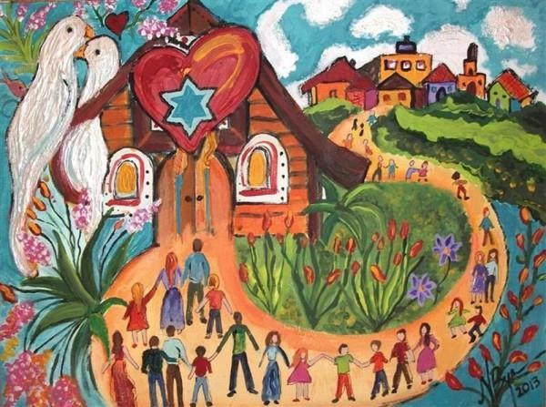

WE WANT YOU TO BE A PART OF THE SHAARAY TEFILA FAMILY!

68 Bay Street, Glens Falls, New York 12801
Phone: 518-792-4945 ● Fax: 518-792-5966
Email: cstgfny@gmail.com
Website: www.shaaraytefila-gfny.org
Facebook: www.facebook.com/shaaray.tefila
Shaaray Tefila, The Center for Jewish Life, is a multigenerational community that creates an atmosphere for the enjoyment of Jewish life and opportunities for spiritual growth.

OUR PHILOSOPHY

Congregation Shaaray Tefila is an inclusive and participatory congregation within the Conservative movement. We welcome all who seek a connection to Jewish life. We are devoted to making Judaism meaningful and accessible within our community. We strive to inspire individuals and families to explore their involvement with Judaism, G-d, Israel, and lifelong Jewish learning. We aspire to conserve and transmit Jewish faith in the belief that Jews share not only a religion, but also language, traditions, culture and ties to Israel.

Our spirited traditional Shabbat services offer intimate opportunities for participatory worship, as well as learning, reflection and spiritual growth. They create a feeling of belonging and caring to strengthen the connections within our close-knit community. These services help us extend Sabbath and festival celebrations to our homes.

Our synagogue is a house of prayer and a home for all.
We offer many opportunities to get involved. In addition to Shabbat and holiday services, we have classes, programs, life cycle events and volunteer activities throughout the year.
We welcome all who seek a connection to Jewish life.

OUR RABBI, STUDENT RABBI RACHEL TALI KAPLAN

A hearty WELCOME to our new Student Rabbi Rachel Tali Kaplan, whose first service with us was Friday, July 26, 2019!  Rachel strives to cultivate Jewish community that is as welcoming as it is meaningful. As she enters her fifth year of Rabbinical School at Hebrew College, she is thrilled to join the Shaaray Tefila community. | 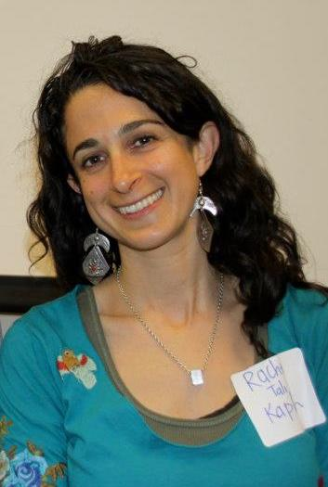

After graduating with a BA in psychology from Grinnell College in Iowa, Rachel worked as the Assistant Director of Hazon, the Jewish lab for sustainability. Steeped in the burgeoning Jewish environmental movement, a path to farming naturally unfolded. After growing her first vegetable as an ADAMAH fellow at the Isabella Freedman Jewish Retreat Center, Rachel spent the next decade working on and managing organic vegetable farms in Georgia and Massachusetts.

Rachel loves exploring the outdoors, sharing time with family and friends, cooking, crafting, running and practicing yoga.

OUR SERVICES

Egalitarian services are held every Shabbat eve and Shabbat morning.
WEEKLY SERVICES
Friday evening . . . . . . . . . . . . .6:30
Saturday morning . . . . . . . . . . 9:30
Bi-weekly Sunday mornings . . . . .9:00-12:00
(Combined Religious School at Temple Beth-El,
3 Marion Avenue, Glens Falls, NY)
On the second Friday of the month, services
are usually held at The Glen at Highland Meadows, Queensbury, at 6:30PM – be sure and check for schedule changes on our website.

- Weekly traditional Shabbat morning services start at 9:30 AM and are followed by a Kiddush luncheon at 11:30 AM, sometimes followed by a lecture or discussion. Services and Torah discussions are participatory and interactive.

- Weekly Friday evening Shabbat services start at 6:30 PM and last about an hour, followed by refreshments and conversation at an informal Oneg Shabbat.

- About once a month, we have an alternative Shabbat evening service, such as Havurat Shabbat, designed and led by congregants; Family Shabbat, in which our youngsters actively participate and apply what they have learned in religious school; Jewish Journey services to engage those less familiar with the traditional service in a welcoming and supportive environment; or Meditation Shabbat. These alternative services tend to be shorter and are often associated with a special Shabbat dinner. We are always interested in learning new melodies and harmonies. During the summer, we hold some Friday night services in Crandall Park.

- Every second Friday of the month, our Shabbat services are held at The Glen at Highland Meadows, 39 Longview Drive, Queensbury, at 6:30 PM. Please check our Weekly Announcements and Monthly Newsletters on our website for schedule changes.

- From Sept-May we hold bi-weekly Sunday Religious School at Temple Beth-El, 3 Marion Avenue, Glens Falls, NY. Check our website, monthly newsletters and weekly announcements for dates.

- Please contact us if you need to say Kaddish so we can make sure we have a minyan.

- We maintain a full schedule of traditional holiday services throughout the year, including a Passover Seder with a catered kosher meal.

- Yizkor (memorial) services are held on Yom Kippur,
Sh’mini Atzeret, the 8th day of Passover, and the 2nd day of Shavuot.

The dates and times of all services and activities are sent by email in weekly announcements and monthly bulletins to all members and anyone who asks to be on our email list. The schedule is also announced at services and is available on our website, Facebook page, the inside and outside bulletin boards, and from the Synagogue office.

Services and Torah discussions are participatory and interactive.

EDUCATIONAL GOALS

We strive to balance the evolving needs of all members of the congregation through educational programs designed to expand their knowledge, regardless of age. We are committed to providing a developmentally appropriate Jewish educational program within a nurturing and friendly environment. Our goals are to help create within our students a strong, positive Jewish identity, to transmit Jewish values, knowledge and beliefs and to foster a lifelong love for and commitment to Jewish education. We consider the home and the synagogue to be partners in the educational process.

We strive to balance the evolving needs of all members of the congregation through
educational programs designed to expand their knowledge, regardless of age.

ADULT EDUCATION

Adult education is about more than education. It is an opportunity for people with an interest in Jewish life to engage with one another intellectually, spiritually, and socially and to gain knowledge and skills that enhance the Jewish experience for us and our community.

Currently, we offer Advanced/Beginner and Intermediate Hebrew classes, as well as a Hebrew literature club that meets after Shabbat morning services. In addition to our weekly discussion of the Torah at morning services, our Student Rabbi leads a monthly “Learning Shabbat.”

RELIGIOUS SCHOOL

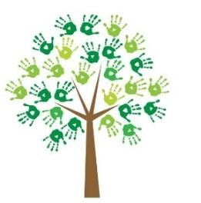

The Synagogue maintains an excellent Jewish education program for its youth based on individualized tutoring in Hebrew and Judaic studies. Preparations for Bar/Bat Mitzvah include individual study with the Rabbi.

We consider the home and the synagogue to be partners in the educational process.

OUR LEADERSHIP AND COMMITTEES

The congregation elects a Board of Directors that includes a president, a vice president, recording secretary, and treasurer who carry out those duties necessary for a smooth running organization. We have several Congregational Meetings a year. In addition, there are standing committees that cover all vital aspects of the Synagogue, including Education, Religious/Ritual, Social, Youth, Library, Fundraising, Cemetery, House, Kitchen, and Membership. All members are encouraged to join one or more committees and take an active part in the organization and activity of the Synagogue.

OUR SISTERHOOD

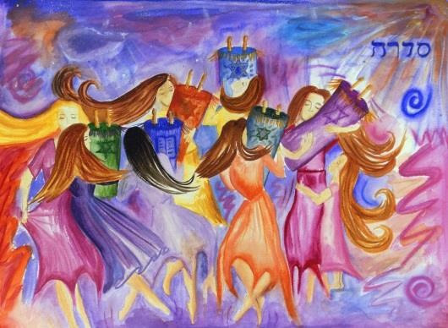

The Sisterhood of Congregation Shaaray Tefila aims to:

- Stimulate Jewish sentiment in the home, observance of home rituals and Kashrut
- Encourage ethical and religious practices in everyday living
- Enhance Jewish education in the family
- Support the observance of the Sabbath and festivals
- Foster a sense of communal responsibility among members
- Sponsor and promote educational and cultural activities in the congregation

Anyone interested in any of these purposes is encouraged to become a member.

SISTERHOOD GIFT SHOP

Congregation Shaaray Tefila has a gift shop in the main lobby that can serve many of your Judaica needs. We have a great selection of jewelry, mezuzahs, candlesticks, books, limited edition items and other beautiful gift items.

If there is an item we do not have in our gift shop, we’ll do our best to find it for you.

The gift shop is open during office hours: Monday-Friday from 9:00AM – 2:00PM. Please call ahead. (518) 792-4945. Gift Certificates are available!

Our synagogue is a house of prayer and a home for all.
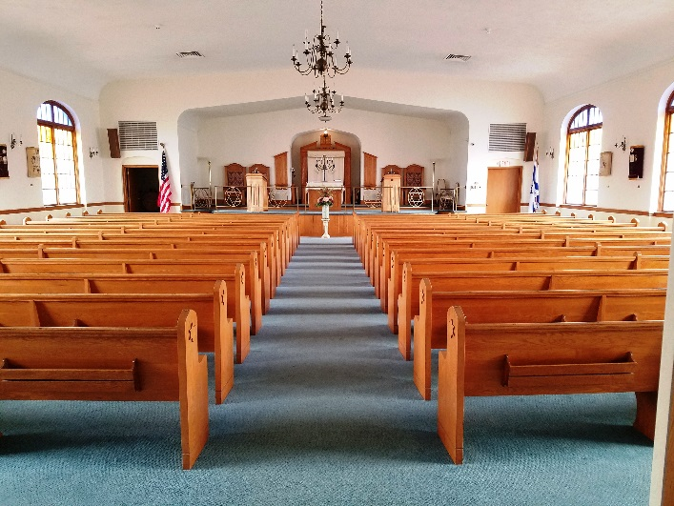

OUR BUILDING
Our building was renovated in 1992 and is handicap accessible with a modern elevator. We have a beautiful main sanctuary with a museum quality collection of Torah Mantels, a small prayer chapel, a large social hall, a youth lounge and classrooms. We also have a modern kosher kitchen and a lending library.

SYNAGOGUE OFFICE

Regular Office Hours: Monday to Friday from 9:00AM until 2:00PM. The office is closed in observance of most Jewish and national holidays.

BENEFITS OF MEMBERSHIP

Here are some opportunities for members and ways to get involved:

- Attend Shabbat, High Holiday and festival services
- Enroll children in our Religious School and Bar/Bat
Mitzvah Program
- Attend congregational holiday celebrations, like
Seders and Sukkah parties
- Hold life-cycle events, such as weddings, Bar/Bat Mitzvahs, baby namings and funerals, in our Sanctuary
- Reserve our social hall for a life-cycle celebration
- Attend congregational social events, like family barbeques and movie viewings
- Participate in adult education classes, including Hebrew classes and Judaic study
- Join our Sisterhood and attend meetings, hear speakers, work on mitzvah projects
- Join our Judaic book club
- Come hear the weekly rehearsal of a Klezmer band led by one of our congregants in our social hall.
- Join a committee and take an active role in the life of the synagogue
- Meet with our rabbi for personal counseling
- Receive marriage preparation and counseling
- Receive advice for Kashrut and where to buy kosher foods
- Receive hospital or home visitation when ill
- Secure a place for burial in our cemetery
- Receive community support while mourning and have a minyan for saying Kaddish
- Receive the monthly newsletter with the Rabbi’s message, President’s message, educational articles, congregational news, calendar of events and more.

We offer many opportunities to get involved.

MEMBERSHIP

We invite you to be a part of the Congregation Shaaray
Tefila family! All Jewish individuals and families, and non- Jewish spouses of members, are eligible to become members of our congregation.

If you are exploring Jewish opportunities in the North Country, join us for services or an event. Or call or e-mail our office, and a member will be happy to contact you and help introduce you to our community. Membership dues are voluntary for those under the age of 50. And for all new members, the first year of membership is free. No one will be excluded from membership due to financial hardship. Our membership form and information are available on our website.

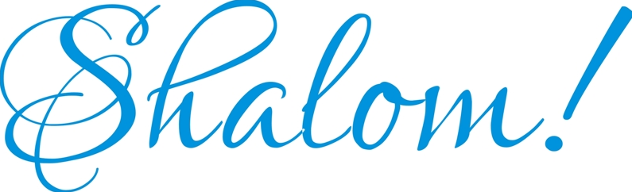

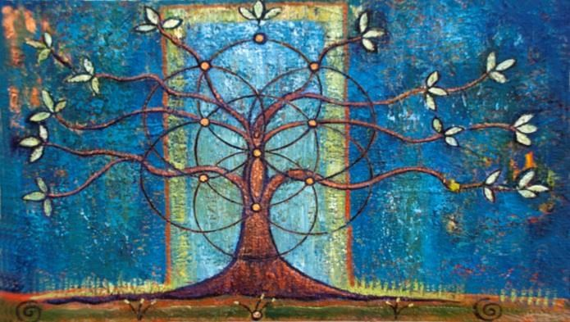

68 Bay Street, Glens Falls, New York 12801
Phone: 518-792-4945 ● Fax: 518-792-5966
Email: cstgfny@gmail.com
Website: www.shaaraytefila-gfny.org

Visit our Facebook page!
Facebook: www.facebook.com/shaaray.tefila

