The First Adult Bat Mitzvahs

On the Shabbat before Rosh Hashanah in September 1988, the first adult Bat Mitzvah took place at Congregation Shaaray Tefila. After months of studying Hebrew together, using their knowledge of music to learn the special melodies (or tropes) of the prayers, Sunny Buchman and Judy Korot celebrated their B’not Mitzvah. Neither Sunny nor Judy had the opportunity to have a Bat Mitzvah as a youngster. It was a formidable accomplishment for each of them.

Years later Sunny and Paul Buchman spent more than a year to help 18 adult women members of the synagogue prepare for their adult Bat Mitzvah. They too had not had the opportunity to have Bat Mitzvahs as youngsters. They learned Hebrew, liturgy, Torah reading, and more. In September, 1998, they celebrated their B’not Mitzvah.

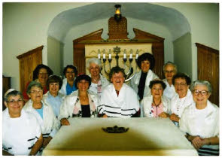
B’not Mitzvah ceremony members (1998):
Rita Spar, Rose Aronson, Mia Corton, Judy Aronson, Bonnie Yanklowitz, Rose Rothstein, Leonore Lebowitz, Harrie Bobbin, Sharon Aronson, Elly Kantrowitz, Eleanor Elliott, Meta Stern and Eadie Green. Not in the picture: Jean Every, Pearl Radin, Sylvia Kudan, Michele Gottlieb and Reva Cohen.

